**Mobile Computing : Introduction**

A technology that is capable of providing an environment which enables users to transmit data from one device to other device without the use of any physical link/cables is known as Mobile Computing.

It means, data transmission is done wirelessly with the help of wireless devices such as mobiles, laptops etc.

Whenever any device is connected to a network without being connected physically over a link or cable, data transmission such as messages, voice recording, videos etc. can be done be done by using the concept of mobile computing.

Mobile Computing technology helps users to access and transmit data from any remote locations without being present there physically.

it is one of the fastest and most reliable sectors of computing technology field

**What is a Network?**

A **network** is a group of interconnected devices (like computers, phones, routers) that communicate to share data and resources (like files, printers, internet).

**Fixed Network (Wired Network)**

**Definition:**

A **fixed network** (also called a **wired network**) uses **physical cables** (like copper wires or fiber optics) to connect devices

**Key Points:**

1. Data transmission occurs through wired mediums like Ethernet or fiber.
2. Provides high reliability and consistent bandwidth.
3. Common in LANs, offices, and data centers.

**Examples:**

* LAN (Local Area Network) using Ethernet cables in offices or homes
* PSTN (Public Switched Telephone Network)
* Fiber-optic broadband connections

**Advantages:**

* High-speed and stable connection
* Low latency and better reliability
* Secure data transmission (harder to intercept physically)

**Disadvantages:**

* No mobility — devices must stay connected by cable
* High setup cost — installing cables is expensive
* Hard to scale — adding devices means more wiring

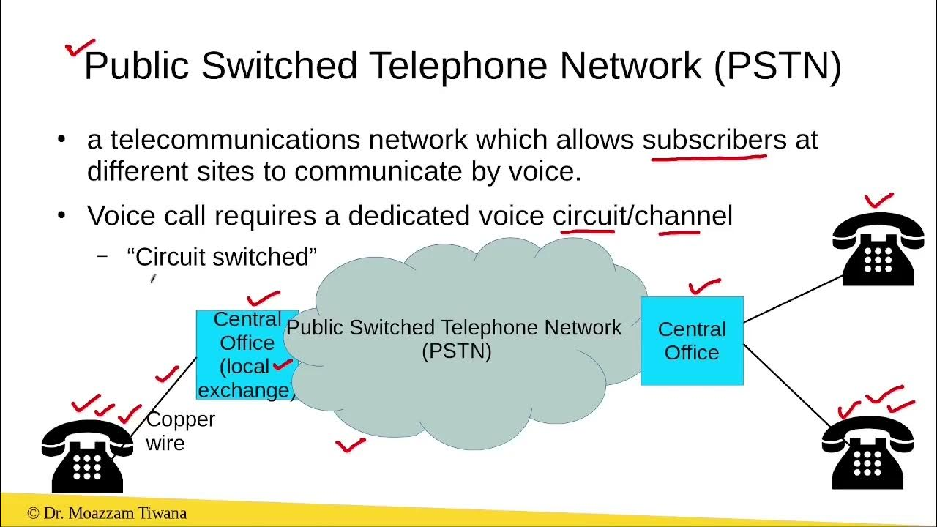

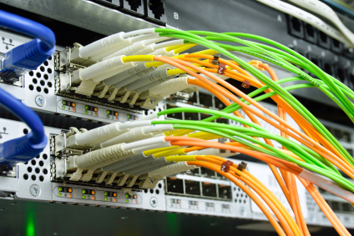

**Wireless Network**

**Definition:**

A wireless network is a communication system where devices are connected without physical cables, using radio waves or infrared signals. It allows user mobility and flexible connectivity.

**Key Points:**

1. Enables mobile communication over Wi-Fi, 4G, 5G, or Bluetooth.
2. Easier and faster to install than fixed networks.
3. Susceptible to interference and requires encryption for security.

**Examples:**

* Wi-Fi (Wireless LAN)
* Mobile networks (2G, 3G, 4G, 5G)
* Bluetooth
* Satellite networks (e.g., GPS)

**Advantages:**

* Mobility — devices can move freely within range
* Easy and quick setup
* Cost-effective for large areas

**Disadvantages:**

* Susceptible to interference and signal loss
* Less secure without encryption (e.g., open Wi-Fi)
* Lower speed and higher latency than wired networks

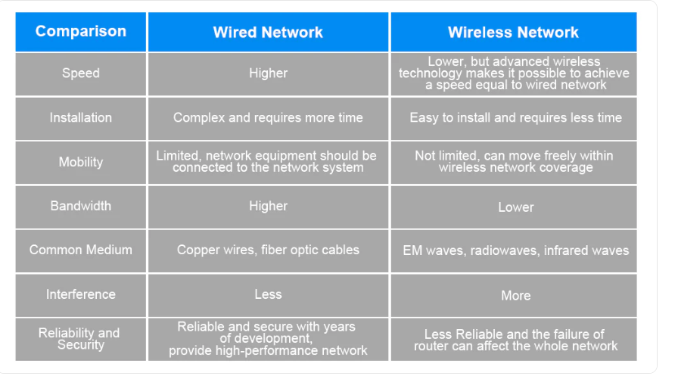

**1.1.2 Introduction of Multiplexing, Modulation**

**Multiplexing :**

Multiplexing in Mobile Computing refers to a technique used to allow multiple signals or data streams to be transmitted over a single communication channel or medium. This is crucial in mobile computing and wireless communication, where bandwidth is limited and efficient usage is necessary

Multiplexing is a method that can be used to combine multiple analog or digital signals into one signal over a shared medium.

The main aim of using this method is to share a scarce resource.

**Purpose**:

* Optimize bandwidth usage.
* Support multiple users/devices on a single channel.
* Improve efficiency and reduce latency.

**Where It's Used**:

* Mobile networks (3G, 4G, 5G)
* Wi-Fi systems
* Satellite communications
* Data transmission in mobile apps and IoT

**Applications in Mobile Computing**

**Voice and video calling**: Multiple calls can occur simultaneously over the same network.

**Internet browsing**: Many users can access the web via shared mobile towers.

**IoT devices**: Efficient communication of thousands of devices using techniques like NB-IoT.

**Modulation :**

Modulation is like putting your message on a radio wave so it can travel through the air to someone else.

Modulation is the process of **varying one or more properties of a carrier signal** (such as amplitude, frequency, or phase) with respect to the data signal.

* Carrier Signal: A high-frequency wave that carries the information.
* Information Signal: The data (voice, video, text) to be transmitted.

**Why Modulation is Important in Mobile Computing**

* Enables wireless transmission over long distances.
* Allows multiple devices to share the same medium.
* Improves signal strength and reduces noise/interference.
* Matches signal characteristics with the medium (e.g., air).

Imagine you're sending a message across a river:

* The boat = carrier wave
* The letter = your data (voice/text)
* Modulation = putting the letter on the boat so it can travel across

Without the boat (modulation), the letter can’t cross the river.

Advantages of Modulation

* By implementing Modulation, the antenna size gets reduced. Before modulation technology, the antenna used for transmission had to be very large. The range of communication gets limited as the wave cannot travel to a distance without getting modulated.
* The range of communication has increased.
* The reception quality is immensely improved.
* Receivers are allowed to adjust to the bandwidth.
* No signal mixing occurs.

**Understanding**

* Modulation = Putting your message in a car to drive on the highway.
* Multiplexing = Letting many cars use the same highway without crashing by staying in different lanes or at different times.
* **Modulation** = How one message is sent.
* **Multiplexing** = How **many** messages are sent **together**

**1.1.3 Fundamentals of spectrum, Bluetooth technology**

Spread Spectrum in Mobile Computing

**Spread Spectrum** is a method used in **wireless communication** to make signals **more secure, reliable, and less affected by noise**.

It helps in reducing noise, improving security, and allowing multiple users.

* Spread Spectrum spreads the signal over a wide frequency range.
* Helps in **secure, reliable wireless communication**.
* Used in **Wi-Fi, Bluetooth, GPS, and mobile networks**.
* Makes the signal **hard to detect or block**.

Example:  
When you connect your phone or laptop to Wi-Fi, the signal between your device and the router is spread across many frequencies, not just one.  
This helps:

* Avoid interference from other nearby devices (like Bluetooth, microwaves, etc.)
* Keep your connection stable and secure.

Example 2:

when a phone connects to a Wi-Fi router, the data is sent over multiple frequencies, not just one, so the connection stays strong even if there is noise from other devices

**Bluetooth Technology in Mobile Computing**

**What is Bluetooth?**

**Bluetooth** is a wireless communication technology used in mobile computing to connect devices like smartphones, laptops, and headphones over short distances.

It is widely used in mobile computing to connect smartphones, laptops, tablets, headphones, smartwatches, and other portable devices.

It is **low-cost, low-power**, and easy to use, but has a limited range and speed.

**How Bluetooth Works**

1. **Radio Waves**: Bluetooth uses **radio waves** in the 2.4 GHz frequency band (the same as Wi-Fi but with different methods).
2. **Pairing Devices**: Devices must be "paired" (connected securely) before sharing data.
3. **Master-Slave Model**:
   * One device acts as the **master** (controller).
   * Others are **slaves** (connected devices).
   * Together, they form a **small network** called a **piconet**.
4. **Frequency Hopping**:
   * Bluetooth uses **Spread Spectrum** with **frequency hopping**.
   * It **changes frequencies 1600 times per second** to avoid interference and improve security.

**Main Purpose of Bluetooth in Mobile Computing**

* To enable wireless communication between devices.
* To support low-power, low-cost connections for data and audio transfer.
* To create personal area networks (PANs), also called piconets.

**Common Uses of Bluetooth in Mobile Computing**

Wireless audio

Example Connecting Bluetooth headphones or speakers to a phone

File sharing

Example Sending photos or documents between smartphones

Advantages of Bluetooth

* **No cables needed (wireless and convenient).**
* **Low power usage (good for mobile devices and battery life).**
* **Inexpensive and easy to use.**
* **Built-in security during pairing and data transfer.**

Limitations of Bluetooth

* **Short range (usually around 10 meters).**
* **Slower data speed compared to Wi-Fi.**
* **May face interference in crowded environments.**